# **Tasks**

**Objective Questions**

1. **What is the total no. of tables present in the data?**

Ans: There are 2 tables that has been provided by Newton School for project details which is having the data for different restaurants across different countries.

1. **What is the total no. of attributes present in the data?**

Ans: The Attributes Refer Here as the Columns= 20.

1. **How many categorical columns are there in the data? [Search about categorical and continuous data, and try to answer this question]**

Ans: The Categorical Columns are Restaurant Name, County, Country Code, City, Locality, Cuisines, Currency, Table Booking, Online Delivery, Delivery is Now, Price Range, Rating, Date Key Opening.

1. **The data consists of some inconsistent and missing values so ensure that the data used for further analysis is cleaned.**

Ans: a. Filled Missing Values cuisines through locality by checking which cuisines is popular in locality and checking the country where the missing value is present, analysing we found that the missing values are present in USA And Most Popular is Mexican Food.

b. Create a Customised Price Column with Currency convert into Indian currency Values.

Then Average Prices Column=Average Price of Two People* Convert Price Column.

C. Opening Date corrected the Extracted year and Month from date column by using the function as TEXT(AB2,"yyyy") and TEXT(AB7,"MMM") OR corrected the date format and extract the year using RIGHT () function.

1. **Using the Look Up functions, fill up the countries in the original data using the country code.**

Ans: The Country Insert in the Data by Using the VLOOKUP

= VLOOKUP (C4,'Country Description'!$A$1:$B$16,2,0)

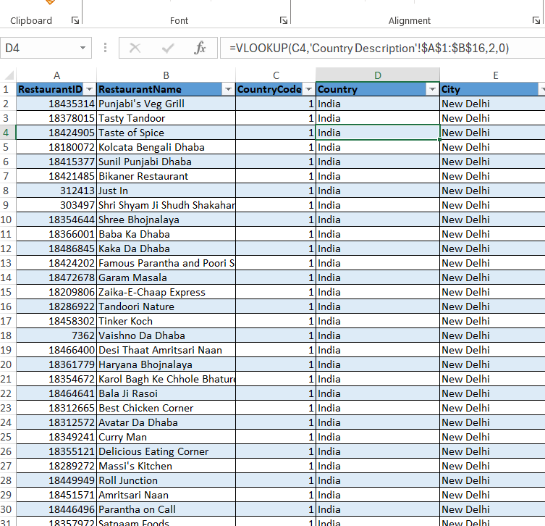

1. **Create a table to represent the number of restaurants opened in each country**.

Ans: The Table Represent the Data of Restaurant Opened in Each Country.

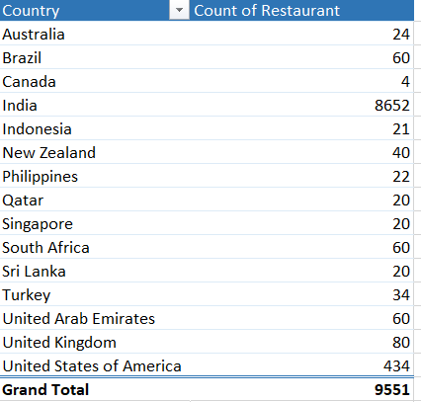

1. **Also, the management wants to look at the number of restaurants opened each year, so provide them with something here**.

Ans: The Table Represent the Year Wise Restaurant Opened.

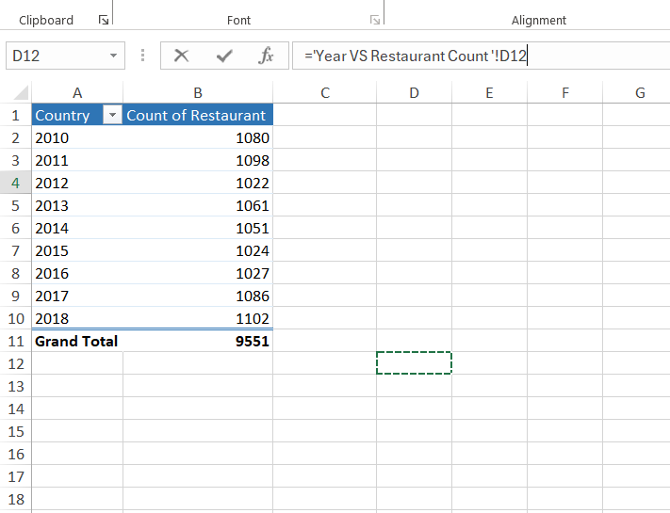

Reference In Excel Sheet: Year-Restaurant

1. **What is the total number of restaurants in India in the price range of 4?**

Ans: The Total Number of Restaurants in Price of 4 With in India is 388

= IF(AND(Q1029=4, D1029="India"),Q1029," ")

Reference in Excel Sheet- Extra Data.

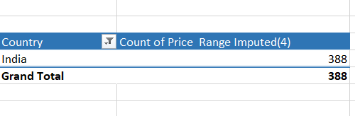

1. **What is the average number of voters for the restaurants in each country according to the data?**

Ans: The Total Average Voters are 156.90

Reference is Excel Sheet- Average Voter-Country

|  |  |
| --- | --- |
| **Country** | **Average of Votes** |
| Australia | 111.4 |
| Brazil | 19.6 |
| Canada | 103.0 |
| India | 137.2 |
| Indonesia | 772.1 |
| New Zealand | 243.0 |
| Philippines | 407.4 |
| Qatar | 163.8 |
| Singapore | 31.9 |
| South Africa | 315.2 |
| Sri Lanka | 146.5 |
| Turkey | 431.5 |
| United Arab Emirates | 493.5 |
| United Kingdom | 205.5 |
| United States of America | 428.2 |
| **Grand Total** | **156.9097477** |

Observation: With the help of pivot table and column chart for Country Indonesia there are maximum number of votes i.e., **772.09** and for Country Brazil there are least number of votes i.e., **19.6**

1. **Calculate the average rating for all the restaurants that have price range < 4 and provide online delivery. Use only the “IF” function, Logical Operators, and Aggregation functions to solve this problem. [Note: Don’t use Conditional aggregation in this question.]**

**Ans:** The Average Rating is = 3.27381151

=AVERAGE(IF(('Zomato Data '!$Q:$Q<4)*('Zomato Data '!$N:$N="Yes"),'Zomato Data '!$Z:$Z))

1. **Using Conditional formatting highlight the rows of restaurants that are located in the countries or cities that you’ve suggested to the management for opening new restaurants.**

Ans:  **Approach**: From Data set of 15 countries and 9551 restaurant we analysis the data and found that the countries with less no. of restaurant and higher rating are best place to established a restaurant.

This is because highly-rated restaurant in a less competitive area can quickly establish a loyal customer base, as there are fewer alternatives Restaurant.

* Analysis the pivot table data and filtering the data on low count of restaurant in given country.

From the data we come up with the names of countries as:

|  |
| --- |
| * 1. Canada |
| * 1. Indonesia |
| * 1. Qatar |
| * 1. Singapore |
| * 1. Sri Lanka |

We have used the formula as:

=OR($A1="Canada",$A1="Qatar",$A1="Indonesia",$A1="Singapore",$A1="Sri Lanka")

Then Sorting the data as per color.

**Excel Sheet References=Conditional Formatting**

1. **Create a new customized price column that consists of the abbreviation/symbol of the currency along with the Average cost for two values [Use string operations to do this task]**

Ans: The New Column Insert with Currency symbol and average cost is being calculate in Indian Currency Rs.

Reference Excel Sheet- Currency Rate.

=CONCATENATE ($T$2, " ", [@[Average Cost of two In Indian Currency2]])

And

=CONCATENATE((MID(G2,FIND("(",G2)+1,FIND(")",G2)-FIND("(",G2)-1))," ",N2)

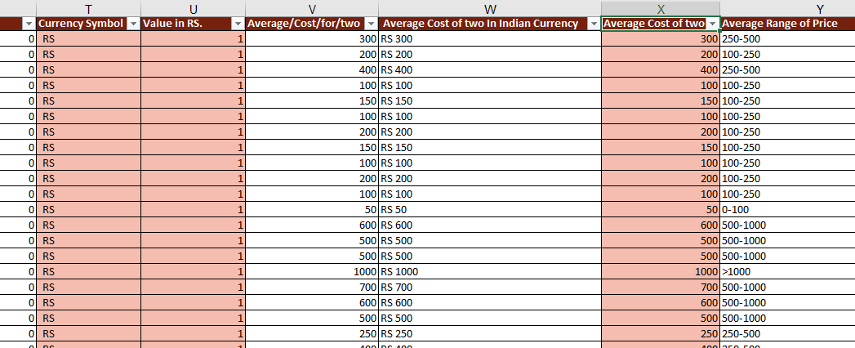

1. **How can you create an array formula in Excel or Google Sheets to count the number of restaurants listed that do not offer online delivery, are in the lowest price range, and have an average cost for two people less than or equal to 250 Indian Rupees?**

Ans: =SUMPRODUCT(($N:$N="No")*($Q:$Q=1)*($X:$X<=250))

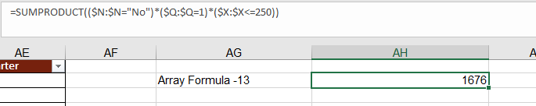

**Subjective Question:**

1. **Suggest a few countries where the team can open newer**

**restaurants with lesser competition. Which visualization/technique will you use here to justify the suggestions?**

Ans

**Approach**: From Data set of 15 countries and 9551 restaurant we analysis the data and found that the countries with less no. of restaurant and higher rating are best place to established a restaurant.

This is because highly-rated restaurant in a less competitive area can quickly establish a loyal customer base, as there are fewer alternatives Restaurant.

* Analysis the pivot table data and filtering the data on low count of restaurant in given country.

From the data we come up with the names of countries as:

|  |
| --- |
| * 1. Canada |
| * 1. Indonesia |
| * 1. Qatar |
| * 1. Singapore |
| * 1. Sri Lanka |

|  |  |  |
| --- | --- | --- |
| Country | Restaurant Count | Rating Average |
| Canada | 4 | 3.6 |
| Indonesia | 21 | 4.3 |
| Qatar | 20 | 4.1 |
| Singapore | 20 | 3.6 |
| Sri Lanka | 20 | 3.9 |
| **Grand Total** | **85** | **3.9** |

**Insight:**

Here We Have seen that the above-mentioned Countries are quite good by average of rating.

So Higher rating and less no. of restaurant gives us an idea about health market and loyal customer.

The Technique used for visualization are the pivot table, Stacked Column.

**Recommendation:**

From the given data the most recommend are Indonesia and Qatar.

* Despite the higher number of restaurants, the strong average rating suggests a healthy market. A new restaurant could succeed if it offers something distinctive or targets a specific niche that’s currently underserved.
* Singapore’s moderate rating average indicates potential for improvement. There may be room for a new establishment that offers a better dining experience or fills a gap in the local cuisine market.

1. **Come up with the names of States and cities in the suggested countries suitable for opening restaurants.**

Ans:

**Approach:**

Here We have created the pivot table of country and their respective cities.

The Next Table Refers the Country, State, Cities of recommended Country

|  |  |  |  |
| --- | --- | --- | --- |
| **Country Name** | **Average of Rating** | **Count of Restaurant** | **Average Cost of two in INR** |
| **Canada** | **3.6** | **4.0** | **2252.9** |
| Chatham-Kent | 3.7 | 1.0 | 1553.8 |
| Consort | 3.0 | 1.0 | 1553.8 |
| Vineland Station | 4.3 | 1.0 | 4350.5 |
| Yorkton | 3.3 | 1.0 | 1553.8 |
| **Singapore** | **3.6** | **20.0** | **10047.4** |
| Singapore | 3.6 | 20.0 | 10047.4 |
| **Sri Lanka** | **3.9** | **20.0** | **665.0** |
| Colombo | 3.9 | 20.0 | 665.0 |
| **Qatar** | **4.1** | **20.0** | **5166.4** |
| Doha | 4.1 | 20.0 | 5166.4 |
| **Indonesia** | **4.3** | **21.0** | **1518.4** |
| Bandung | 4.2 | 1.0 | 810.0 |
| Bogor | 3.9 | 2.0 | 864.0 |
| Jakarta | 4.4 | 16.0 | 1665.6 |
| Tangerang | 4.3 | 2.0 | 1350.0 |
| **Grand Total** | **3.9** | **85.0** | **4217.4** |

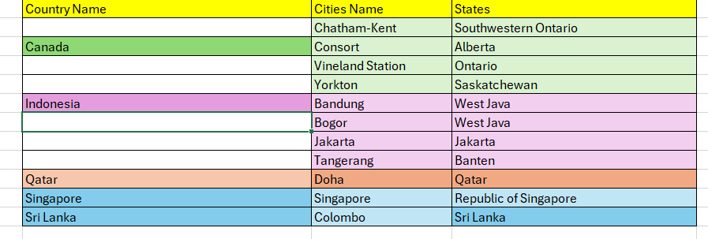

**Insights-**

1. Top Ratings and Costs:
   * Indonesia has the highest rating (4.3) with a relatively low average cost for two (₹1,518.4). This indicates it’s a highly satisfying and affordable destination.
   * Vineland Station (Canada)-has a notable rating of 4.3 but a higher cost (₹4,350.5) despite having only one restaurant, suggesting it may cater to a niche market.
2. Dining Options:
   * Singapore and Sri Lanka both have a significant number of restaurants (20), but Singapore’s costs (₹10,047.4) are much higher compared to Sri Lanka (₹665.0). This could make Sri Lanka a more appealing option for food lovers on a budget.
3. Restaurant Density vs. Satisfaction:
   * Qatar and Indonesia both boast high ratings (4.1 and 4.3 respectively) with a good number of dining options (20 and 21), indicating strong culinary offerings.
   * Colombo and Sri Lanka offer good ratings at a much lower price, potentially making them attractive for travelers looking for both quality and value.
4. General Trends:
   * Higher restaurant counts often correlate with better ratings, but this is not a strict rule (e.g., Canada with fewer restaurants but a lower rating).

**Recommendation**:

* Indonesia’s Value: Highlight Indonesia’s high satisfaction rating and low cost in marketing campaigns. Emphasize the diverse culinary experiences available.
* Singapore’s Offering: Address the high costs of dining in Singapore. Consider partnerships with restaurants to offer promotional deals or packages that enhance value.
* Sri Lanka for Budget Travelers: Given its affordability and good ratings, promote Sri Lanka as a top destination for food lovers seeking budget-friendly options.
* Qatar: For Qatar, emphasize the quality of dining experiences in marketing materials, potentially creating packages that include dining tours or culinary experiences to attract visitors.
* Canada: Investigate why Canada has a lower rating despite the number of restaurants. Gather traveler feedback to improve perceptions and enhance the overall experience.

1. **According to the countries you suggested, what is the current quality regarding ratings for restaurants that are open there?**

Ans

**Approach:**

We have created a Pivot table of Country and the average rating.

|  |  |
| --- | --- |
| Country | Rating Average |
| Canada | 3.6 |
| Indonesia | 4.3 |
| Qatar | 4.1 |
| Singapore | 3.6 |
| Sri Lanka | 3.9 |

**Average Rating in Smallest to largest--**

|  |  |
| --- | --- |
| Country | Rating Average |
| Canada | 3.6 |
| Singapore | 3.6 |
| Sri Lanka | 3.9 |
| Qatar | 4.1 |
| Indonesia | 4.3 |

**Insight:**

Highest Rated:

* Indonesia (4.3) stands out as the highest-rated destination, suggesting strong traveler satisfaction and appealing experiences.
* Qatar (4.1) also received a high rating, indicating good quality despite higher costs.

Lowest Rated:

* Both Canada and Singapore share the lowest rating (3.6), which may reflect traveler expectations versus experience.

Moderate Ratings:

* Sri Lanka (3.9) and Indonesia are well-rated while remaining relatively affordable, making them attractive for travelers seeking value.

**Recommendation:**

* Here the average rating for the given country is good which shows that the loyalty of customer towards the respective restaurant.
* The quality of food which is offered here is good.

1. **Also, what is the current expenditure on food in the suggested countries, so we can keep our financial expenditure in control?**

Ans

**Approach:**  From the data we have created a pivot table of country and average cost (INR).

We have converted the currency values/Average Cost of two into the Indian Currency

|  |  |  |
| --- | --- | --- |
| Country | Currency Symbol | Conversion Rate (INR) |
| Australia | AUD | 56.46 |
| Brazil | BRL | 14.88 |
| Canada | CAD | 62.15 |
| India | INR | 1 |
| Indonesia | IDR | 0.0054 |
| New Zealand | NZD | 52.11 |
| Philippines | PHP | 1.49 |
| Qatar | QAR | 23.09 |
| Singapore | SGD | 64.51 |
| South Africa | ZAR | 4.72 |
| Sri Lanka | LKR | 0.28 |
| Turkey | TRY | 2.47 |
| United Arab Emirates | AED | 22.87 |
| United Kingdom | GBP | 110.54 |
| United States of America | USD | 83.98 |

After the conversion we have take the pivot table of recommended country and their average cost of two in Indian currency.

|  |  |
| --- | --- |
| **Country Name** | **Average Cost In INR** |
| Australia | 1359.7 |
| Brazil | 2003.8 |
| Canada | 2252.9 |
| India | 624.1 |
| Indonesia | 1518.4 |
| New Zealand | 3634.7 |
| Philippines | 2394.2 |
| Qatar | 5166.4 |
| Singapore | 10047.4 |
| South Africa | 1981.1 |
| Sri Lanka | 665.0 |
| Turkey | 209.6 |
| United Arab Emirates | 3805.9 |
| United Kingdom | 5285.2 |
| United States of America | 2226.4 |
| **Grand Total** | **822.2** |

|  |  |
| --- | --- |
| **Country Name** | **Average Cost In INR** |
| Canada | 2252.9 |
| Indonesia | 1518.4 |
| Qatar | 5166.4 |
| Singapore | 10047.4 |
| Sri Lanka | 665.0 |
| **Grand Total** | **4217.4** |

**Insights-**

1. Cost Variability: There is significant variability in average costs across the countries listed:
   * Highest: Singapore (₹10,047.4)
   * Lowest: Sri Lanka (₹665.0)
   * Mid-range: Canada (₹2,252.9), Indonesia (₹1,518.4), and Qatar (₹5,166.4).
2. Affordability: Sri Lanka is the most affordable destination, making it an attractive option for budget travelers. In contrast, Singapore stands out as the most expensive, which may limit accessibility for some.

**Recommendations-**

1. Target Budget Travelers: If focusing on budget-conscious travelers, prioritize promoting destinations like Sri Lanka and Indonesia. These offer lower costs while still providing rich cultural experiences.
2. Luxury Packages: For high-end travel, create exclusive packages for Singapore and Qatar, where travelers might be willing to spend more for unique experiences.
3. Cost Awareness: When marketing travel options, provide clear comparisons of costs across different countries to help travelers make informed decisions.
4. Promotional Deals: Consider partnerships with hotels or attractions in countries like Canada and Indonesia to offer promotional deals, enhancing their attractiveness.
5. Research Trends: Monitor trends in travel preferences and costs, especially post-pandemic, as this may influence travel choices and affordability.
6. **Come up with the names of restaurants from the recommended states that are our biggest competitors and also those that are rated in the lower brackets, i.e. 1-2 or 2-3.**

**Ans**

**Approach:**

For finding the competitor and those in lower brackets we made the pivot table for the recommended country with their restaurant name and their average rating then after that we have applied the conditional formatting based on the average rating of restaurant

Here we have highlighted the good rating with green color then moderate rating with yellow and the final rating with red

This are the Top 5 Restaurant Name of each suggested country with average rating as 3+. These have been the biggest competitor in suggested country

|  |  |  |
| --- | --- | --- |
| **Country Name** | **Average of Rating** | **Count of Restaurant** |
| **Canada** | **3.6** | **4.0** |
| Lake House Restaurant | 4.3 | 1.0 |
| Tokyo Sushi | 3.7 | 1.0 |
| Arigato Sushi | 3.3 | 1.0 |
| Consort Restaurant | 3.0 | 1.0 |
| **Indonesia** | **4.8** | **7.0** |
| Sushi Masa | 4.9 | 1.0 |
| Talaga Sampireun | 4.9 | 3.0 |
| Satoo - Hotel Shangri-La | 4.6 | 1.0 |
| Union Deli | 4.6 | 1.0 |
| Toodz House | 4.6 | 1.0 |
| **Qatar** | **4.6** | **5.0** |
| Mainland China Restaurant | 4.9 | 1.0 |
| Gymkhana | 4.7 | 1.0 |
| Zaffran Dining Experience | 4.6 | 1.0 |
| Paper Moon | 4.5 | 1.0 |
| Vine - The St. Regis | 4.4 | 1.0 |
| **Singapore** | **4.0** | **6.0** |
| Al'frank Cookies | 4.2 | 1.0 |
| Fratini La Trattoria | 4.1 | 1.0 |
| Cut By Wolfgang Puck | 4.0 | 1.0 |
| Bitters & Love | 3.9 | 1.0 |
| Summer Pavilion | 3.9 | 1.0 |
| Rhubarb Le Restaurant | 3.9 | 1.0 |
| **Sri Lanka** | **4.4** | **6.0** |
| Ministry of Crab | 4.9 | 1.0 |
| Simply Strawberries By Jagro | 4.5 | 1.0 |
| The Sizzle | 4.2 | 1.0 |
| Butter Boutique | 4.2 | 1.0 |
| Arabian Knights | 4.2 | 1.0 |
| Cricket Club Cafe | 4.2 | 1.0 |
| **Grand Total** | **4.3** | **28.0** |

**Insight:**

• **Top-Performing Country:**

* **Indonesia** stands out with the highest average rating (4.8) and has a strong representation of restaurants with ratings above 4.6, indicating a vibrant culinary scene.

• **Areas for Improvement:**

* **Canada** has the lowest average rating (3.6), suggesting potential challenges in restaurant quality or customer satisfaction. The ratings of individual restaurants also vary widely, with the highest at 4.3 and the lowest at 3.0.

• **Consistent Quality:**

* **Qatar** shows a good balance with an average rating of 4.6 across five restaurants, indicating consistency in quality. This could attract more visitors looking for reliable dining experiences.

• **Moderate Ratings:**

* **Singapore** and **Sri Lanka** both maintain average ratings around 4.0 and 4.4, respectively. While not the highest, there is a range of restaurants that provide decent experiences.

**Lower Bracket Restaurant--**

|  |  |  |  |  |
| --- | --- | --- | --- | --- |
| **Restaurant -Name** | **Rating** |  |  |  |
| **Country Name** | **2-3** | **3-4** | **4-5** | **Grand Total** |
| **Canada** |  | **3.0** | **1.0** | **4.0** |
| Arigato Sushi |  | 1.0 |  | 1.0 |
| Consort Restaurant |  | 1.0 |  | 1.0 |
| Lake House Restaurant |  |  | 1.0 | 1.0 |
| Tokyo Sushi |  | 1.0 |  | 1.0 |
| **Indonesia** |  | **4.0** | **17.0** | **21.0** |
| 3 Wise Monkeys |  |  | 1.0 | 1.0 |
| Avec Moi Restaurant and Bar |  |  | 1.0 | 1.0 |
| Fish Streat |  | 1.0 | 1.0 | 2.0 |
| Flip Burger |  |  | 1.0 | 1.0 |
| Lemongrass |  |  | 1.0 | 1.0 |
| Lucky Cat Coffee & Kitchen |  |  | 1.0 | 1.0 |
| Momo Milk |  | 1.0 |  | 1.0 |
| MONKS |  |  | 1.0 | 1.0 |
| Noah's Barn Coffeenery |  |  | 1.0 | 1.0 |
| OJJU |  | 1.0 |  | 1.0 |
| Onokabe |  | 1.0 |  | 1.0 |
| Satoo - Hotel Shangri-La |  |  | 1.0 | 1.0 |
| Skye |  |  | 1.0 | 1.0 |
| Sushi Masa |  |  | 1.0 | 1.0 |
| Talaga Sampireun |  |  | 3.0 | 3.0 |
| Toodz House |  |  | 1.0 | 1.0 |
| Union Deli |  |  | 1.0 | 1.0 |
| Zenbu |  |  | 1.0 | 1.0 |
| **Qatar** |  | **9.0** | **11.0** | **20.0** |
| 7st by Mumbai Spices |  | 1.0 |  | 1.0 |
| Aalishan |  | 1.0 |  | 1.0 |
| Applebee's |  | 1.0 |  | 1.0 |
| Coral - InterContinental Doha |  | 1.0 |  | 1.0 |
| Eatopia |  | 1.0 |  | 1.0 |
| Gokul Gujarati Restaurant |  |  | 1.0 | 1.0 |
| Gymkhana |  |  | 1.0 | 1.0 |
| Indian Coffee House |  | 1.0 |  | 1.0 |
| Mainland China Restaurant |  |  | 1.0 | 1.0 |
| MRA Bakery Sweets & Restaurant |  |  | 1.0 | 1.0 |
| Paper Moon |  |  | 1.0 | 1.0 |
| Ponderosa |  | 1.0 |  | 1.0 |
| Punjab Restaurant |  | 1.0 |  | 1.0 |
| Roti & Boti |  | 1.0 |  | 1.0 |
| Sabai Thai - The Westin Doha Hotel & Spa |  |  | 1.0 | 1.0 |
| Texas Roadhouse |  |  | 1.0 | 1.0 |
| The Manhattan FISH MARKET |  |  | 1.0 | 1.0 |
| Vine - The St. Regis |  |  | 1.0 | 1.0 |
| Zaffran Dining Experience |  |  | 1.0 | 1.0 |
| Zaoq |  |  | 1.0 | 1.0 |
| **Singapore** |  | **17.0** | **3.0** | **20.0** |
| Al'frank Cookies |  |  | 1.0 | 1.0 |
| Artichoke Cafe |  | 1.0 |  | 1.0 |
| Artistry |  | 1.0 |  | 1.0 |
| Bitters & Love |  | 1.0 |  | 1.0 |
| Boufe Boutique Cafe |  | 1.0 |  | 1.0 |
| Chye Seng Huat Hardware |  | 1.0 |  | 1.0 |
| Colony |  | 1.0 |  | 1.0 |
| Cut By Wolfgang Puck |  |  | 1.0 | 1.0 |
| Fratini La Trattoria |  |  | 1.0 | 1.0 |
| I Am |  | 1.0 |  | 1.0 |
| Jaan |  | 1.0 |  | 1.0 |
| Makansutra Gluttons Bay |  | 1.0 |  | 1.0 |
| Potato Head Folk |  | 1.0 |  | 1.0 |
| Restaurant Andre |  | 1.0 |  | 1.0 |
| Rhubarb Le Restaurant |  | 1.0 |  | 1.0 |
| Sky On 57 |  | 1.0 |  | 1.0 |
| Summer Pavilion |  | 1.0 |  | 1.0 |
| Super Loco |  | 1.0 |  | 1.0 |
| The Lokal |  | 1.0 |  | 1.0 |
| The Refinery Singapore |  | 1.0 |  | 1.0 |
| **Sri Lanka** | **2.0** | **5.0** | **13.0** | **20.0** |
| Arabian Knights |  |  | 1.0 | 1.0 |
| Burger's King |  |  | 1.0 | 1.0 |
| Butter Boutique |  |  | 1.0 | 1.0 |
| Cafe Beverly |  |  | 1.0 | 1.0 |
| Cafe Shaze |  | 1.0 |  | 1.0 |
| Carnival Ice Cream |  |  | 1.0 | 1.0 |
| Chinese Dragon Cafe |  | 1.0 |  | 1.0 |
| CIOCONAT Lounge |  | 1.0 |  | 1.0 |
| Cricket Club Cafe |  |  | 1.0 | 1.0 |
| Elite Indian Restaurant | 1.0 |  |  | 1.0 |
| Malay Restaurant |  | 1.0 |  | 1.0 |
| Ministry of Crab |  |  | 1.0 | 1.0 |
| Queen's Cafe | 1.0 |  |  | 1.0 |
| Simply Strawberries By Jagro |  |  | 1.0 | 1.0 |
| T.G.I. Friday's |  |  | 1.0 | 1.0 |
| The Commons |  |  | 1.0 | 1.0 |
| The Manhattan FISH MARKET |  |  | 1.0 | 1.0 |
| The Paddington |  | 1.0 |  | 1.0 |
| The Sizzle |  |  | 1.0 | 1.0 |
| Upali's |  |  | 1.0 | 1.0 |
| **Grand Total** | **2.0** | **38.0** | **45.0** | **85.0** |

There are 2 Restaurant of Sri Lanka Which are in the Lower Bracket 2-3.

|  |  |
| --- | --- |
| Restaurant -Name | Rating |
| Country Name | 2-3 |
| Canada |  |
| Arigato Sushi |  |
| Consort Restaurant |  |
| Lake House Restaurant |  |
| Tokyo Sushi |  |
| Indonesia |  |
| 3 Wise Monkeys |  |
| Avec Moi Restaurant and Bar |  |
| Fish Streat |  |
| Flip Burger |  |
| Lemongrass |  |
| Lucky Cat Coffee & Kitchen |  |
| Momo Milk |  |
| MONKS |  |
| Noah's Barn Coffeenery |  |
| OJJU |  |
| Onokabe |  |
| Satoo - Hotel Shangri-La |  |
| Skye |  |
| Sushi Masa |  |
| Talaga Sampireun |  |
| Toodz House |  |
| Union Deli |  |
| Zenbu |  |
| Qatar |  |
| 7st by Mumbai Spices |  |
| Aalishan |  |
| Applebee's |  |
| Coral - InterContinental Doha |  |
| Eatopia |  |
| Gokul Gujarati Restaurant |  |
| Gymkhana |  |
| Indian Coffee House |  |
| Mainland China Restaurant |  |
| MRA Bakery Sweets & Restaurant |  |
| Paper Moon |  |
| Ponderosa |  |
| Punjab Restaurant |  |
| Roti & Boti |  |
| Sabai Thai - The Westin Doha Hotel & Spa |  |
| Texas Roadhouse |  |
| The Manhattan FISH MARKET |  |
| Vine - The St. Regis |  |
| Zaffran Dining Experience |  |
| Zaoq |  |
| Singapore |  |
| Al'frank Cookies |  |
| Artichoke Cafe |  |
| Artistry |  |
| Bitters & Love |  |
| Boufe Boutique Cafe |  |
| Chye Seng Huat Hardware |  |
| Colony |  |
| Cut By Wolfgang Puck |  |
| Fratini La Trattoria |  |
| I Am |  |
| Jaan |  |
| Makansutra Gluttons Bay |  |
| Potato Head Folk |  |
| Restaurant Andre |  |
| Rhubarb Le Restaurant |  |
| Sky On 57 |  |
| Summer Pavilion |  |
| Super Loco |  |
| The Lokal |  |
| The Refinery Singapore |  |
| Sri Lanka | 2 |
| Arabian Knights |  |
| Burger's King |  |
| Butter Boutique |  |
| Cafe Beverly |  |
| Cafe Shaze |  |
| Carnival Ice Cream |  |
| Chinese Dragon Cafe |  |
| CIOCONAT Lounge |  |
| Cricket Club Cafe |  |
| Elite Indian Restaurant | 1 |
| Malay Restaurant |  |
| Ministry of Crab |  |
| Queen's Cafe | 1 |
| Simply Strawberries By Jagro |  |
| T.G.I. Friday's |  |
| The Commons |  |
| The Manhattan FISH MARKET |  |
| The Paddington |  |
| The Sizzle |  |
| Upali's |  |
| Grand Total | 2 |

1. **Diverse Offerings:**
   * **Indonesia** features a wide range of restaurants (19 total), showcasing a vibrant culinary landscape. This diversity can attract both locals and tourists.
2. **Qatar’s Robust Selection:**
   * With 28 restaurants, Qatar provides a variety of dining options, reflecting a multicultural environment. Many of these establishments are rated highly, indicating a strong food culture.
3. **Moderate Performance in Canada:**
   * Canadian restaurants show a mix of ratings, with several below 4.0. This suggests that while there are standout venues, others may need improvement.
4. **Sri Lanka’s Unique Position:**
   * Sri Lanka has fewer restaurants (13) but includes high-rated venues like Ministry of Crab, which can serve as flagship experiences for attracting food enthusiasts.
5. **Potential for Growth in Singapore:**
   * Singapore features a solid lineup of restaurants, with many rated around 4.0. There's room for growth by enhancing unique dining experiences and culinary innovations.

**Recommendation:**

* + - 1. Focus on Quality and Service
      2. Marketing and Branding.

1. **Which cuisines should we focus on in the newer restaurants to get better feedback? Does the choice of cuisines affect the restaurant ratings?**

Ans:

**Approach:**

Here the approach which we have taken is creating pivot table based on the country’s most favourite cuisines. Here we have taken the top 5 values of cuisines from each recommended country by their average rating.

|  |  |
| --- | --- |
| **Country Name** | **Average of Rating** |
| **Canada** | **3.6** |
| Chinese, Canadian | 3.0 |
| Asian | 3.3 |
| Japanese, Sushi | 3.7 |
| Italian, Mediterranean, Pizza | 4.3 |
| **Indonesia** | **4.8** |
| Desserts, Bakery, Western | 4.6 |
| Asian, Indonesian, Western | 4.6 |
| Cafe, Italian, Coffee and Tea, Western, Indonesian | 4.6 |
| Sunda, Indonesian | 4.9 |
| Sushi, Japanese | 4.9 |
| **Qatar** | **4.3** |
| International | 4.1 |
| Indian | 4.2 |
| Thai | 4.3 |
| Italian | 4.5 |
| Chinese | 4.9 |
| **Singapore** | **4.0** |
| Chinese, Seafood, Cantonese, Dim Sum | 3.9 |
| Finger Food | 3.9 |
| American, Steak | 4.0 |
| Italian | 4.1 |
| Bakery | 4.2 |
| **Sri Lanka** | **4.4** |
| Desserts, Bakery | 4.2 |
| American, Fast Food, Steak, Beverages | 4.2 |
| Middle Eastern, Arabian | 4.2 |
| Continental, American, Seafood | 4.2 |
| Juices, Desserts | 4.5 |
| Seafood | 4.9 |
| **Grand Total** | **4.3** |

**Insight:**

From the above data we come up with cuisines which needs to added to the menu of restaurant respective to their country.

**Recommendation:**

The list of cuisines with average rating more than 4 in respective county,

|  |  |
| --- | --- |
| Canada | Italian, Mediterranean, Pizza |
|  |  |
| Indonesia | Asian, Indonesian, Western |
|  | Cafe, Italian, Coffee and Tea, Western, Indonesian |
|  | Desserts, Bakery, Western |
|  | Sunda, Indonesian |
|  | Sushi, Japanese |
| Qatar | Chinese |
|  | Indian |
|  | International |
|  | Italian |
|  | Thai |
| Singapore | American, Steak |
|  | Bakery |
|  | Italian |
| Sri Lanka | American, Fast Food, Steak, Beverages |
|  | Continental, American, Seafood |
|  | Desserts, Bakery |
|  | Juices, Desserts |
|  | Middle Eastern, Arabian |
|  | Seafood |

**Impact:**

Overall, the choice of cuisine can greatly influence a restaurant's ratings, shaped by factors such as cultural familiarity, ingredient quality, menu, and market trends.

1. **According to our current data, should we go for online delivery and table booking? Does that affect the customer’s ratings?**

Ans: Approach:

Here we have taken two different pivot table as the table should consist the value of restaurant with online delivery and another table should consist the value of table booking and they average rating

Insight:

From the pivot table we have seen that the recommended countries don’t have the online delivery option.

|  |  |  |
| --- | --- | --- |
| Country | Restaurant Count | Average of Rating |
| Canada | 4 | 3.6 |
| No | 4 | 3.6 |
| Indonesia | 21 | 4.3 |
| No | 21 | 4.3 |
| Qatar | 20 | 4.1 |
| No | 20 | 4.1 |
| Singapore | 20 | 3.6 |
| No | 20 | 3.6 |
| Sri Lanka | 20 | 3.9 |
| No | 20 | 3.9 |
| **Grand Total** | **85** | **3.9** |

This below table shows that the count of restaurant that offer online delivery in whole data

|  |  |
| --- | --- |
| No | 7100 |
| Yes | 2451 |
| **Grand Total** | **9551** |

From the pivot table we have seen that the recommended countries and table Booking option.

|  |  |  |
| --- | --- | --- |
| Country | Restaurant Count | Average of Rating |
| Canada | 4 | 3.6 |
| No | 4 | 3.6 |
| Indonesia | 21 | 4.3 |
| No | 21 | 4.3 |
| Qatar | 20 | 4.1 |
| No | 19 | 4.0 |
| Yes | 1 | 4.7 |
| Singapore | 20 | 3.6 |
| No | 20 | 3.6 |
| Sri Lanka | 20 | 3.9 |
| No | 20 | 3.9 |
| **Grand Total** | **85** | **3.9** |

This below table shows that the count of restaurant that offer table booking in whole data.

|  |  |
| --- | --- |
| Table Booking | Restaurant With Booking |
| No | 8393 |
| Yes | 1158 |
| **Grand Total** | **9551** |

**Recommendation:**

As we analysis the data we come up with conclusion that the online delivery and table booking plays a vital role in the rating of a restaurant apart from another factors.

So, for a new restaurant the online delivery and table booking will increases the rating and customer gathering which will eventually grow the business of restaurant.

1. **Should the team keep the rate of cuisines higher? Will that affect the feedback? According to our data are the rates of cuisines and ratings, correlated?**

Ans

**Approach:** It is better to understand that the pricing which is given in the data are not appropriate so we have converted the pricing into a standard format that is the Indian currency.

- So first we have converted the currency into Indian currency so that the comparison is easier.

- For that we have a table encompassing the relation between the average ratings with price segment they exist and value in INR.

We have used correlation formula to check out relation between the rating and pricing.

For Reference Excel Sheet—Extra Subjective

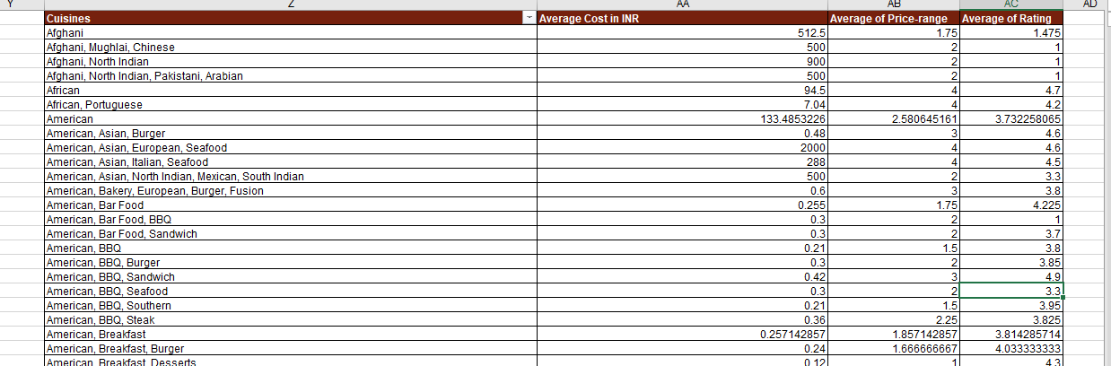

Insight: Here are top 10 cuisines average rating.

So as the data we have seen that the Pricing is low where as the average rating is high.

|  |  |  |  |
| --- | --- | --- | --- |
| **Cuisines** | **Average Cost in INR** | **Average of Price-range** | **Average of Rating** |
| American, BBQ, Sandwich | 0.42 | 3 | 4.9 |
| American, Burger, Grill | 0.45 | 3 | 4.9 |
| American, Caribbean, Seafood | 0.48 | 3 | 4.9 |
| American, Coffee and Tea | 0.3 | 2 | 4.9 |
| American, Sandwich, Tea | 0.3 | 2 | 4.9 |
| BBQ, Breakfast, Southern | 0.12 | 1 | 4.9 |
| Burger, Bar Food, Steak | 0.48 | 3 | 4.9 |
| Continental, Indian | 7.04 | 3 | 4.9 |
| European, Asian, Indian | 960 | 4 | 4.9 |
| European, Contemporary | 323.4 | 4 | 4.9 |
| European, German | 0.48 | 3 | 4.9 |
| Hawaiian, Seafood | 0.84 | 4 | 4.9 |
| Italian, Bakery, Continental | 2000 | 4 | 4.9 |
| Italian, Deli | 0.12 | 1 | 4.9 |
| Mexican, American, Healthy Food | 500 | 2 | 4.9 |
| Mughlai, Lucknowi | 300 | 1 | 4.9 |
| Sunda, Indonesian | 36322000 | 3 | 4.9 |
| World Cuisine | 32.8 | 3 | 4.9 |
| **Grand Total** | **5448506.362** | **2.75** | **4.9** |

**Correlation:** -3.88676993533807E-17.

= CORREL($AA$4:$AA$22,$AC$4:$AC$22)

**-Top 10 Average price cuisines**

|  |  |  |  |
| --- | --- | --- | --- |
| **Cuisines** | **Average Cost in INR** | **Average of Price-range** | **Average of Rating** |
| Asian, Indonesian, Western | 145288000 | 3 | 4.6 |
| Cafe, Western | 54483000 | 3 | 4.3 |
| Desserts, Bakery, Western | 36322000 | 3 | 4.6 |
| French, Western | 63563500 | 3 | 4.3 |
| Indonesian | 54483000 | 3 | 3.7 |
| Japanese, Sushi, Ramen | 36322000 | 3 | 4.4 |
| Peranakan, Indonesian | 45402500 | 3 | 4 |
| Sunda, Indonesian | 36322000 | 3 | 4.9 |
| Sushi, Japanese | 45402503.96 | 3.5 | 4.2 |
| Western, Asian, Cafe | 45402500 | 3 | 4.2 |
| **Grand Total** | **52387500.61** | **3.076923077** | **4.4** |

**=CORREL($AA$4:$AA$22,$AC$4:$AC$22)**

-0.172005799.

Since the correlation is close to zero, it implies that price has little to no effect on the average rating in the dataset.

* **1** indicates a perfect positive correlation.
* **-1** indicates a perfect negative correlation.
* **0** indicates no correlation

**Recommendation:**

As Per Analyzing the data we found that the Restaurant in the price range of 2-3 are having moderate rating.

The count of restaurant in the price range 2-3 are comparatively good.

* By focusing on higher-rated cuisines, offering a unique dining experience, and actively engaging with the community a new restaurant will succeed

|  |  |  |
| --- | --- | --- |
| **Price Range** | **Count of Cuisines** | **Average of Rating** |
| 1 | 4444 | 2.4 |
| 2 | 3113 | 3.1 |
| 3 | 1408 | 3.7 |
| 4 | 586 | 3.8 |
| **Grand Total** | **9551** | **2.9** |

1. What is the distribution of the number of restaurants of different price ranges in all the countries?

Approach: From data set we will insert a pivot table using the price range and count of restaurant with respective to country.

|  |  |  |  |  |  |
| --- | --- | --- | --- | --- | --- |
| **Countries** | **Price Range** |  |  |  |  |
|  | **1** | **2** | **3** | **4** | **Grand Total** |
| Australia | 4 | 14 | 5 | 1 | 24 |
| Brazil | 2 | 7 | 16 | 35 | 60 |
| Canada |  | 3 |  | 1 | 4 |
| India | 4295 | 2858 | 1111 | 388 | 8652 |
| Indonesia |  | 1 | 20 |  | 21 |
| New Zealand | 3 | 4 | 17 | 16 | 40 |
| Philippines |  | 1 | 12 | 9 | 22 |
| Qatar |  | 1 | 5 | 14 | 20 |
| Singapore |  | 1 | 5 | 14 | 20 |
| South Africa |  | 4 | 17 | 39 | 60 |
| Sri Lanka |  | 6 | 11 | 3 | 20 |
| Turkey |  | 11 | 18 | 5 | 34 |
| United Arab Emirates |  | 9 | 29 | 22 | 60 |
| United Kingdom | 4 | 28 | 32 | 16 | 80 |
| United States of America | 136 | 165 | 110 | 23 | 434 |
| **Grand Total** | **4444** | **3113** | **1408** | **586** | **9551** |

The Count of Restaurant in the Price Range-

|  |  |
| --- | --- |
| **Price Range** | **Restaurant Count** |
| 1 | 4444 |
| 2 | 3113 |
| 3 | 1408 |
| 4 | 586 |
| **Grand Total** | **9551** |

**Insight:**

As Per the data we have seen that the no. of restaurant in low price Range are more and the no. of restaurant in the higher price range are less.

**Recommendation:**

**Focusing on Price Range 1:**

* This range has the highest number of restaurants, suggesting a strong market.
* Here we can come up with good quality of food and other services.

**Elevate the Experience in Price Range 4:**

* Focus on providing a high-end experience with exceptional service and ambiance.

**10.** Explain your approach in brief for suggesting countries/cities in order to open new restaurants, if the objective and subjective questions would have not been given to assist you. [you have to give bullet pointers in order to answer this question]

Ans - First I will try to get familiar with data and understand the key point

* The second part is looking for the duplicate and inconsistent values and then replacing them appropriately by applying different excel function and visualization techniques.
* Insertion of pivot table after the data analysis and the table which consists the key point values.
* Pivot table -Count of restaurant, rating, cuisines etc.
* focusing on the countries in which the average rating is good where the count of restaurant is less and we will serve the most quality in those countries.
* Focusing on the cuisines which is most favorite in that location.
* Focusing then on online delivery and table booking option through this we will come up to a country which needs to be suggested for opening new restaurant.
* Chart insertion would be done as per required key points.
* Final step would be the creation of dashboard.